**Entity Relationship Diagram for Lift system**

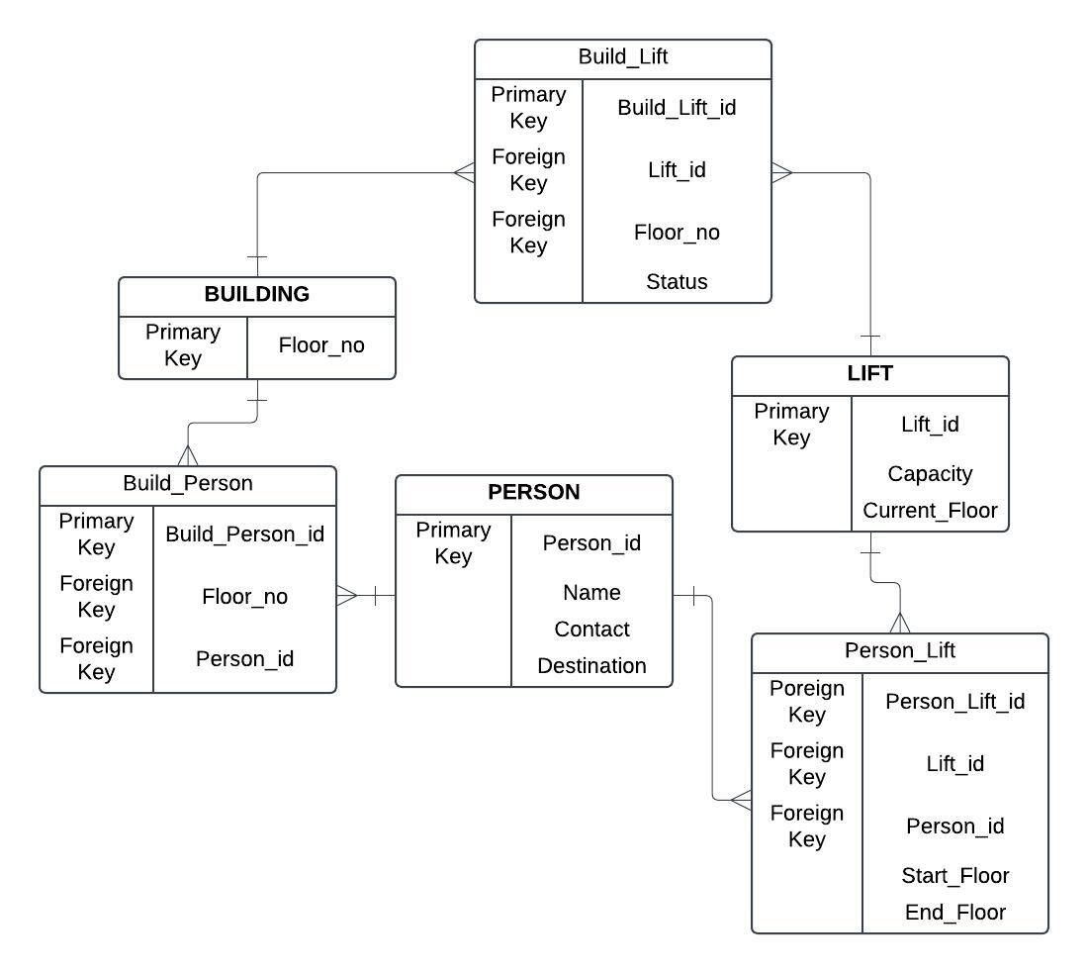

* Person_Lift track which person uses which lift and travel details.
* Build_Lift tracks which lift is serving which floor.
* Build_Person tracks which person visits which floor.

**Database creation**

CREATE TABLE Building ( floor_no INTEGER PRIMARY KEY NOT NULL );

CREATE TABLE Person (

person_id INTEGER PRIMARY KEY AUTOINCREMENT,

name VARCHAR(50) NOT NULL,

contact VARCHAR(15),

destination INT

);

CREATE TABLE Lift (

lift_id INTEGER PRIMARY KEY AUTOINCREMENT,

capacity INT NOT NULL,

current_floor INT NOT NULL

);

CREATE TABLE Build_Person(

Build_Person_id INTEGER PRIMARY KEY AUTOINCREMENT,

person_id INT NOT NULL,

floor_no INT NOT NULL,

FOREIGN KEY (person_id) REFERENCES Person(person_id),

FOREIGN KEY (floor_no) REFERENCES Building(floor_no)

);

CREATE TABLE Build_Lift (

lift_build_id INTEGER PRIMARY KEY AUTOINCREMENT,

lift_id INT NOT NULL,

floor_no INT NOT NULL,

status VARCHAR(20) NOT NULL,

FOREIGN KEY (lift_id) REFERENCES Lift(lift_id),

FOREIGN KEY (floor_no) REFERENCES Building(floor_no)

);

CREATE TABLE Person_Lift (

person_lift_id INTEGER PRIMARY KEY AUTOINCREMENT,

lift_id INT NOT NULL,

person_id INT NOT NULL,

start_floor INT NOT NULL,

end_floor INT NOT NULL,

FOREIGN KEY (lift_id) REFERENCES Lift(lift_id),

FOREIGN KEY (person_id) REFERENCES Person(person_id)

);

**Inserting Values into Tables**

INSERT INTO Building (floor_no)

VALUES

(1),

(2),

(3),

(4),

(5);

INSERT INTO Person (name, contact, destination)

VALUES

('pradeep', '1234567890', 1),

('abhishek', '9876543210', 5),

('arjun', '4567891230', 2),

('moiz', '7891234560', 4),

('parth', '3216549870', 3);

INSERT INTO Lift (capacity, current_floor)

VALUES

(10, 1),

(8, 3),

(15, 2),

(12, 4),

(6, 5);

INSERT INTO Build_Person (person_id, floor_no)

VALUES

(1, 1),

(2, 2),

(3, 3),

(4, 4),

(5, 5);

INSERT INTO Build_Lift (lift_id, floor_no, status)

VALUES

(1, 1, 'active'),

(2, 2, 'active'),

(3, 3, 'inactive'),

(4, 4, 'active'),

(5, 5, 'maintenance');

INSERT INTO Person_Lift (lift_id, person_id, start_floor, end_floor)

VALUES

(1, 1, 1, 1),

(2, 2, 3, 5),

(3, 3, 2, 2),

(4, 4, 4, 3),

(5, 5, 5, 4);

**Queries and there output**

SELECT * FROM Person;

1|pradeep|1234567890|1

2|abhishek|9876543210|5

3|arjun|4567891230|2

4|moiz|7891234560|4

5|parth|3216549870|3

SELECT bp.Build_Person_id, p.name, b.floor_no

FROM Build_Person bp

JOIN Person p ON bp.person_id = p.person_id

JOIN Building b ON bp.floor_no = b.floor_no;

1|pradeep|1

2|abhishek|2

3|arjun|3

4|moiz|4

5|parth|5

SELECT p.name, p.contact, p.destination

FROM Person p

WHERE p.destination = 5;

abhishek|9876543210|5

SELECT l.lift_id, l.capacity, l.current_floor

FROM Lift l

WHERE l.capacity > 10;

3|15|2

4|12|4

UPDATE Build_Lift

SET status = 'active'

WHERE lift_id = 3;

SELECT status FROM Build_Lift ;

active

active

Active (updated)

active

maintenance

SELECT floor_no, COUNT(person_id)

FROM Build_Person

GROUP BY floor_no;

1|1

2|1

3|1

4|1

5|1

SELECT destination, COUNT(person_id)

FROM Person

GROUP BY destination;

1|1

2|1

3|1

4|1

5|1

SELECT current_floor, SUM(capacity)

FROM Lift

GROUP BY current_floor;

1|10

2|15

3|8

4|12

5|6